**Performance Reviews Actually Matter Even More When Employees Are Working From Home**

Yes, I know, everybody hates performance reviews. In fact, in the study New Data Reveals Why Employees And Managers Dislike Performance Appraisals, we discovered that only 13% of employees and managers think their organization's performance appraisal system is useful.

But that’s because performance reviews are poorly implemented; not because they’re not necessary. And when employees are working from home, the feedback that could come from a well-delivered performance review is absolutely critical.

In the study Fewer Than Half Of Employees Know If They’re Doing A Good Job, we discovered that only 29% of employees know whether their performance is where it should be. And that’s not just bad for the company, it’s terrible for employees’ mental health.

Have you ever tried to learn a new skill? Have you ever felt the frustration of having no idea whether you’re doing it right, or whether there’s a better way to go about it? That’s the feeling that more than two-thirds of employees have right now as they’re working from home; trying to separate work and home, optimize their productivity, establish routines, and more

In the past few months, employees have been asked to adopt new ways of working that are different than, or even antithetical to, the way they’ve operated for years. Previously an employee would come into a discrete space (the office) for a discrete period of time (the working day). But now, work is neither in a discreet place nor for a discreet period of time. Work takes place at home and can seem never-ending.

And even if an employee is coming into the office, policies and procedures have changed so significantly in response to the pandemic that the workplace may bear little resemblance to the office of 2019.

Work has changed dramatically, and employees are being asked to adapt and learn at a breakneck pace. All that adapting and learning comes with uncertainty, anxiety and a need for copious amounts of coaching and feedback. And if that feedback and coaching isn’t there, employees are just left with the uncertainty and anxiety.

This isn’t mere conjecture. For example, look at the statistical relationship between knowing whether your performance is where it should be and being inspired at work.

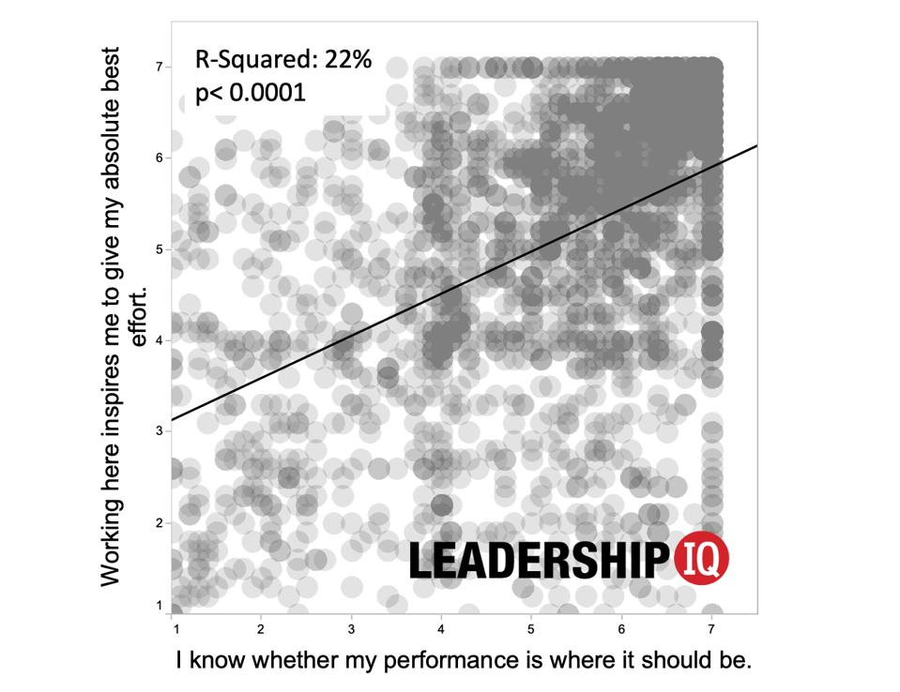

You can see that the more an employee has clarity about their performance, the more inspired they are. And by extension, the less clear they are, the less inspired they are.

Hopefully it’s clear why employees actually need performance reviews. But how can managers conduct these conversations without furthering the painful drudgery that describes today’s typical review? By following these four steps:

First, even though we often call these conversations “performance reviews,” and that implies a historical look backwards, we actually want these conversations to look forwards not backwards.

Employees can’t change the past (nor can anyone else, for that matter). But we can change the future. We can improve the quality of our work, learn a few new tricks to maximize productivity, create better barriers between work and home, and more. And that means that this poorly-named “performance review” conversation should really be a “let me help you get better” conversation.

The second step is to pinpoint what, precisely, is causing your employees the most frustration. And this is really as simple as asking them, “could you tell me about your biggest frustration over the past few weeks?”

I want to ask a pointed question that quickly and directly surfaces their current pain. What I don’t want to do is ask something like “how’s it going?” That’s a conversation ritual (or phatic communication). It’s merely a social lubricant and the equivalent of saying hello.

Third, once I know what areas are causing my employees the most stress, I’m going to help them solve those issues. And this is, for most leaders, a pleasant and easy activity. Chances are that you’ve experienced these challenges yourself at some point, or you’re connected to people who have good solutions. As long as your goal is truly to help your employee feel less frustrated, they should welcome your input.

In the fourth, and final, step, you’re going to offer some feedback about your employee’s performance. Perhaps this was covered in the previous step; it’s not unusual for an employee’s biggest source of stress to also be your biggest source of frustration with their performance. But in the event that this hasn’t already been covered, you’re going to provide feedback here.

It might strike you as odd that I’ve waited until the final step to offer the kind of feedback that permeates the typical performance review. In most performance review conversations, there’s a unidirectional flow of information: The manager gives feedback and the employee takes it.

But the goal here is to both help my employee improve their performance and make this conversation pleasant. I want them to feel like there’s a clear path, with easily identifiable steps, to improvement.

I don’t want to spend thirty minutes telling them why last month’s performance was so poor. Instead, I want to share that last month’s performance was below where it needed to be and then, I want to spend the bulk of our conversation collaborating with them to find ways to elevate their performance.

Remember that the purpose here is not to make employees feel bad. They likely would appreciate getting some honest feedback and some practical coaching about how to get better. The data is quite clear that the more an employee has clarity about their performance, the more inspired they are.

**Questions**

1. Do you think that performance review matter more when employees are working from home?

YES! That is so because it is set and aligned when an employee works under regular situations when he comes to a cubical office. There's a certain day you're going to arrive, the same day to go, the days are set. In the opposite, time, location and days are not set when an individual works from home. In the workplace, there are no rules like that because it is your own location. Because of these alterations, there will probably be a difference in results, if not a lot, either positive or poor. To cater to this, performance reviews are becoming much more relevant in home practice.

1. What kind of challenges do employees facing while working from home? What changes have occurred due to working from home?

Work has changed drastically, and workers are being asked at a breakneck pace to adapt and understand. Uncertainty, anxiety and a desire for copious amounts of coaching and feedback come with all the adapting and learning. And if the input and coaching is not there, the confusion and anxiety are left to staff.

1. Do you think that employees’ clarity about their performance standards can reduce their anxiety about their performance appraisals? If yes, why?

At the conclusion of an employee's assessment period, managers typically perform a structured appraisal interview. The employee should be made transparent as to what the conference is about. Usually, workers know when their interview can take place, and if their boss delays the appointment, their frustration continues to escalate. For anyone involved, conversations with top stars are always fun encounters.

1. How difficult has it become to appraise the employees working from home?

It is really difficult to determine workers who work from home or evaluate employees that are not in the workplace, but because wo do not notice if they get through with their job, so if they offer a result that is achieved, at that stage we can assume that they do their job properly.

1. Can performance review termed as *look backward* be turned into *look forward*? What does it mean? Discuss.

We also call these conversations "performance reviews," because that means the true look in reverse, we just need the discussions not to look in reverse for progresses. Staff are powerless to alter the history (nor can any other individual, besides). Yet, we will transform the future. We will enhance the essence of the task, get acquainted with a few new tricks to maximize performance, make the best hindrance among work and home.